|  |  |  |  |  |  |
| --- | --- | --- | --- | --- | --- |
| **#** | **Test Case** | **Expected Result** | **Actual Result** | **Proof** | **Pass/Fail** |
| 1 | The login in page will be displayed when the user goes to play the game. | When the user goes to play the game, the first page they are taken to is the login page. | Expected result. | Figure: 5 | Pass |
| 2 | The login page has an option for new users to be able to create a new user profile. | An option to create a new profile will be visible on the staring screen. | Expected result. | Figure: 5 | Pass |
| 3 | When the user clicks the sign up button on the startup screen it will take the user to a new page that will ask for user information to create a user profile. | The new page will load when the sign up button is clicked. | Expected result. | Figure: 4, 5 | Pass |
| 4 | When the user try’s to login, it will notify the user if the login was successful or not | Upon successful login, the user is taken to the message on the status of the login. | Expected result. | Figure: 1, 2, 5 | Pass |
| 5 | The user would be able to select the difficulty of the puzzle when they get to the game board. | The user was able to select the difficulty of the puzzle. | Expected result. | Figure: 3 | Pass |
| 6 | The user will be able to start a new game when they are playing the game. The button will be visible the whole time. | The user is able to see the button to start a new game. | Expected Result | Figure: 3 | Pass |
| 7 | The user will be able to see a load game button to load an unfinished game from before. | The user was able to see the load game button. | Expected Result | Figure: 3 | Pass |
| 8 | The user will be able to see the high score from the previous players visible to all times to try to achieve a score that is higher than the pervious. | The user is able to see the high score at all time. | Expected Result | Figure: 3 | Pass |

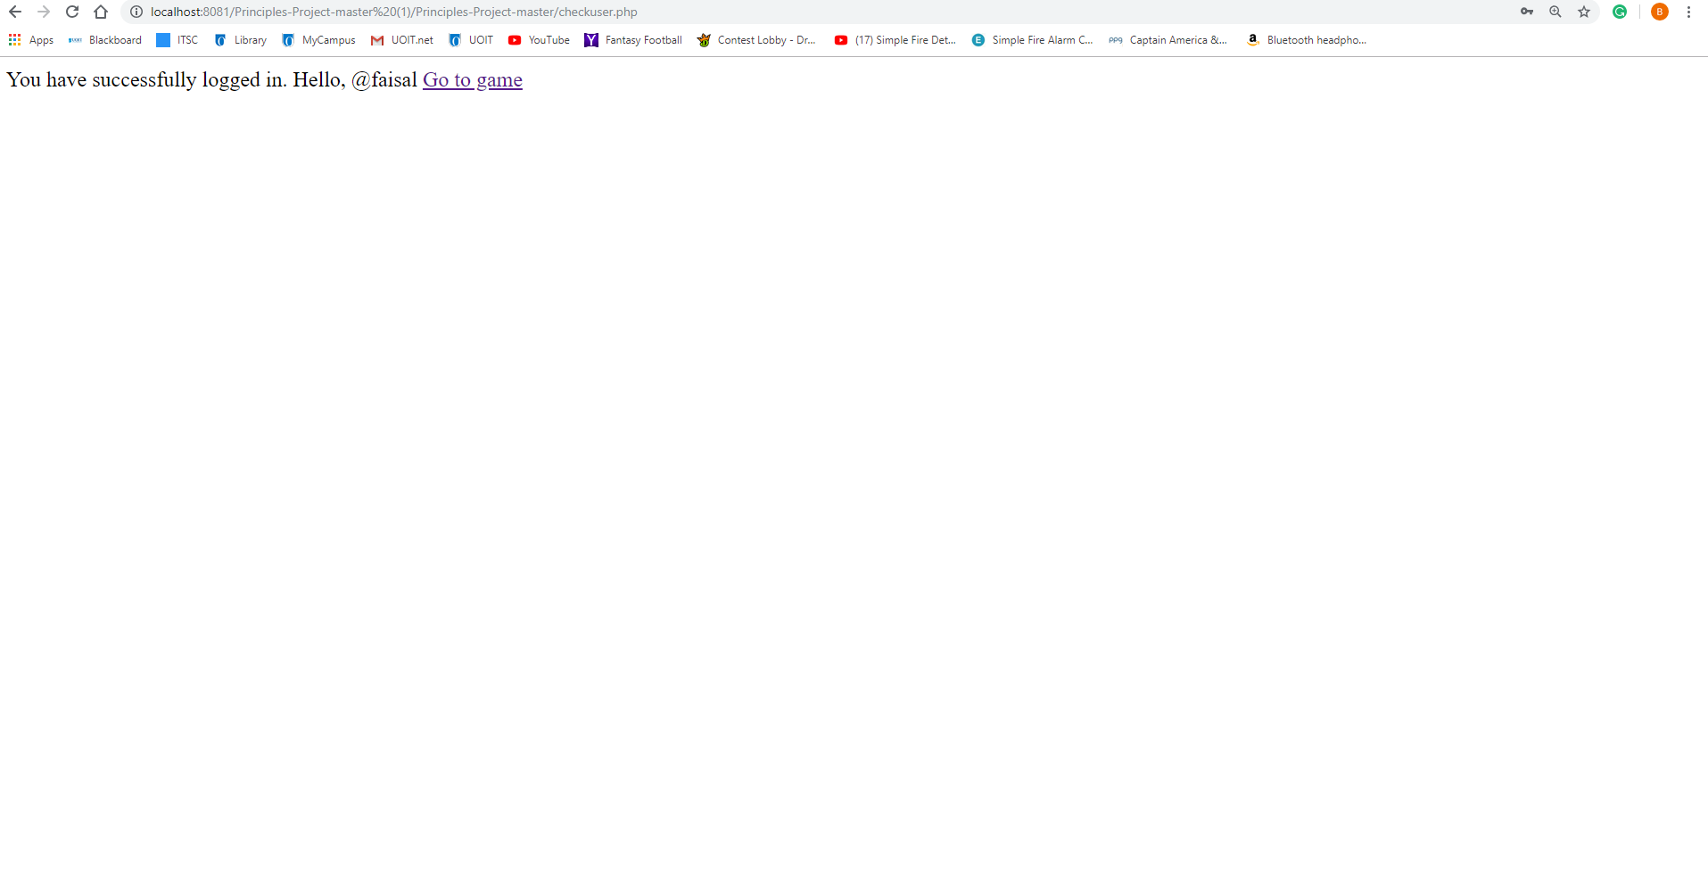

Figure 1: The message displayed after you have successfully logged in

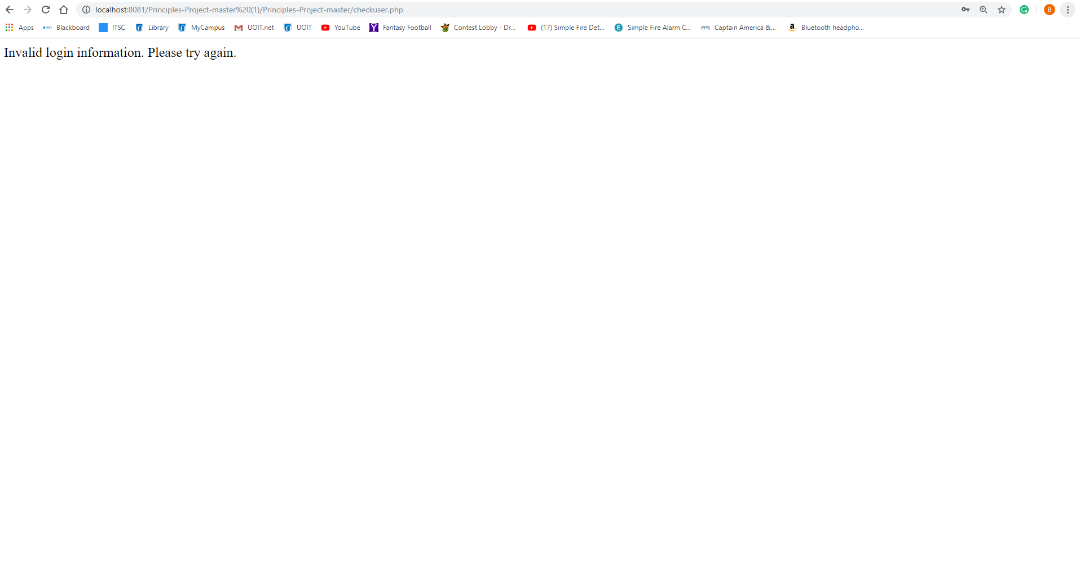

Figure 2: The message after an in correct login

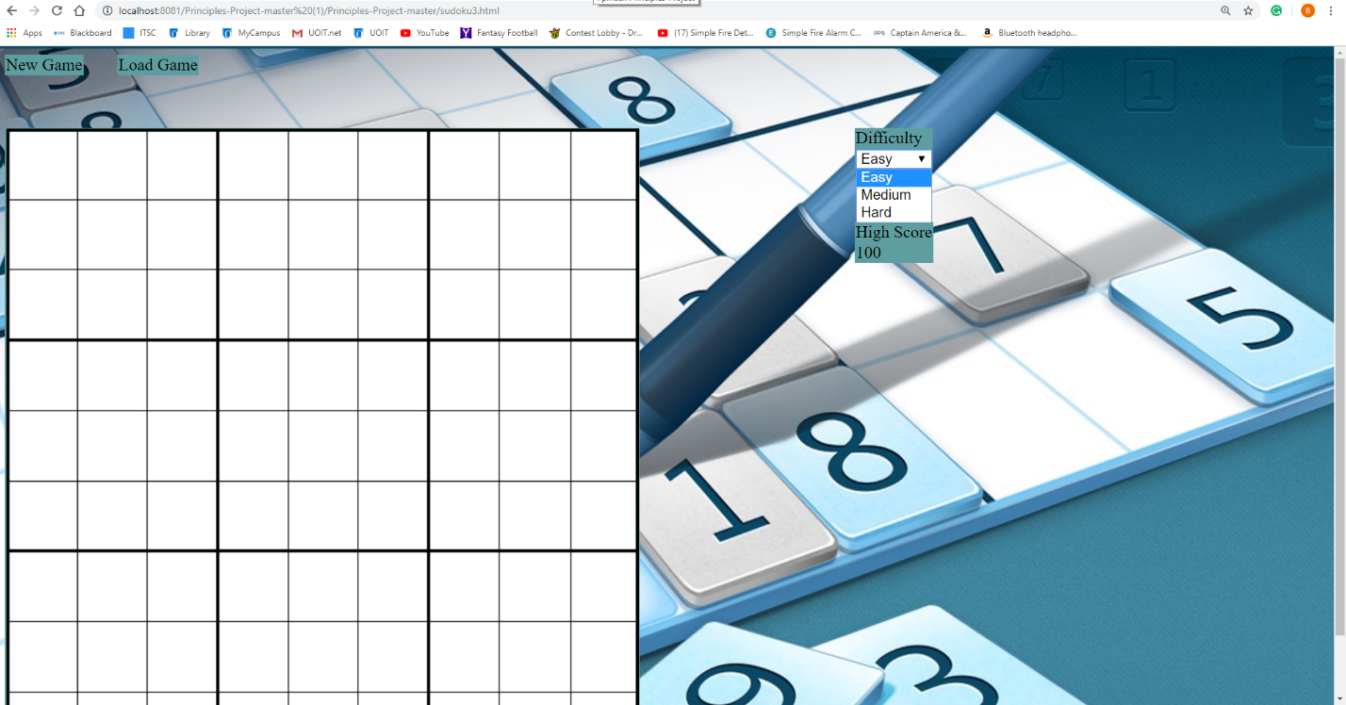

Figure 3: The main game screen

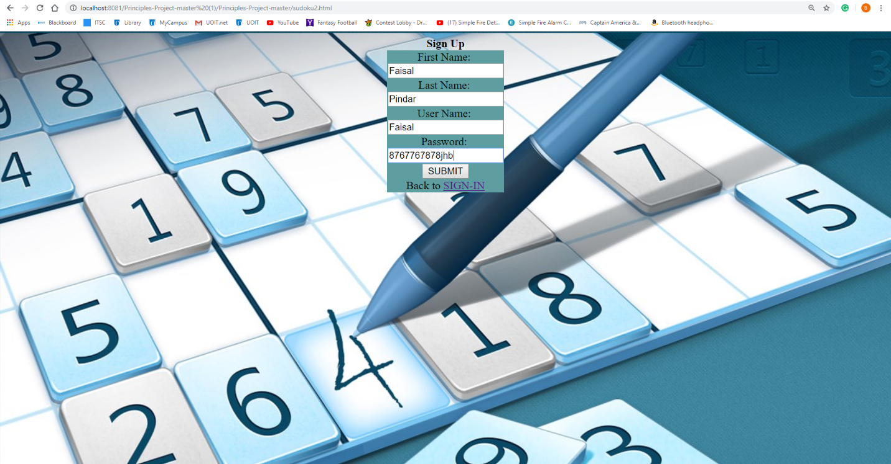

Figure 4: The sign up screen for user profile

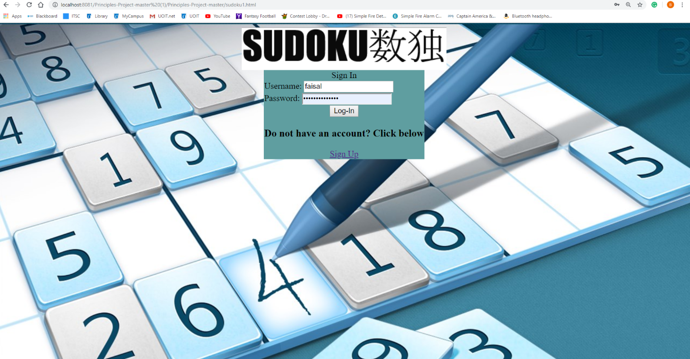

Figure 5: The login screen for the game